DATABASE SYSTEMS ENGINEERING AND DISTRIBUTED BACKEND DEVELOPMENT

TOPIC: JOINS AND SET OPERATIONS

2520030413 – CH. KAVYA SREE

QUESTION 1 - CROSS JOIN

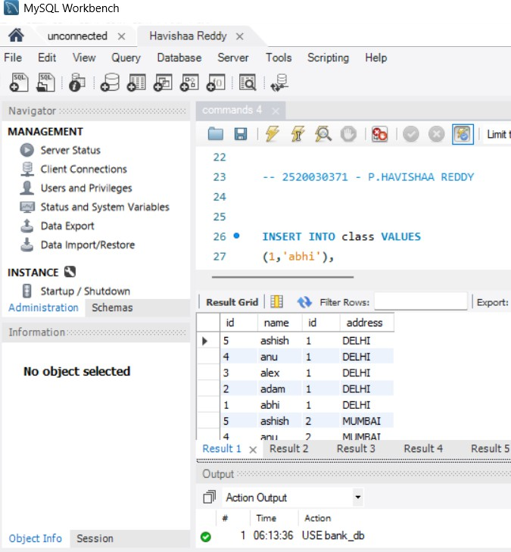

QUESTION 2 - INNER JOIN
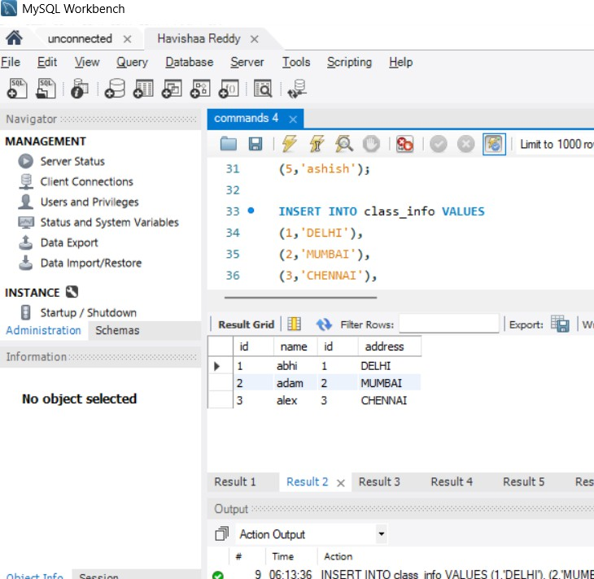

QUESTION 3 - INNER JOIN

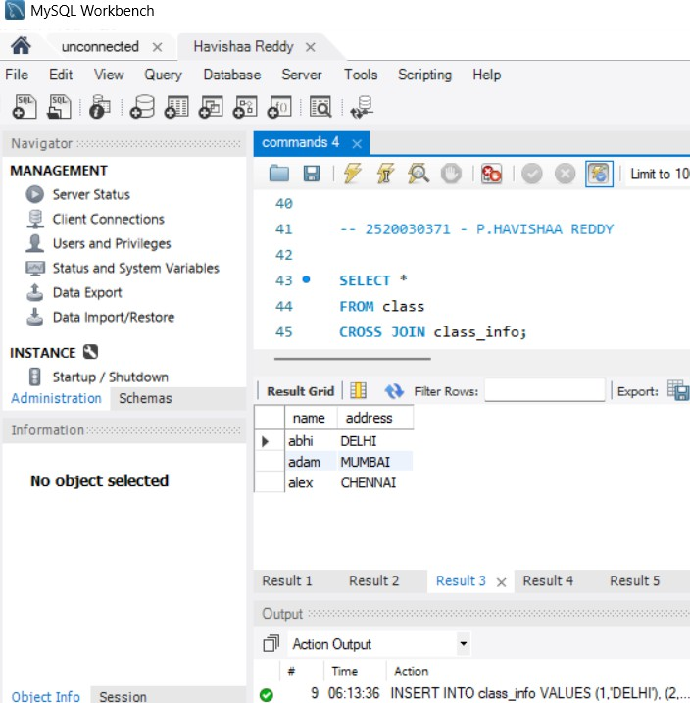

QUESTION 4 - NATURAL JOIN

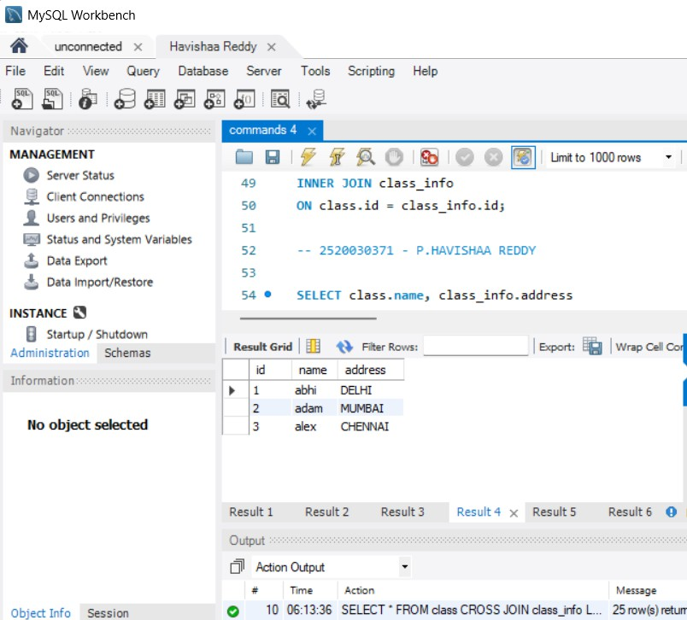

QUESTION 5 - LEFT JOIN

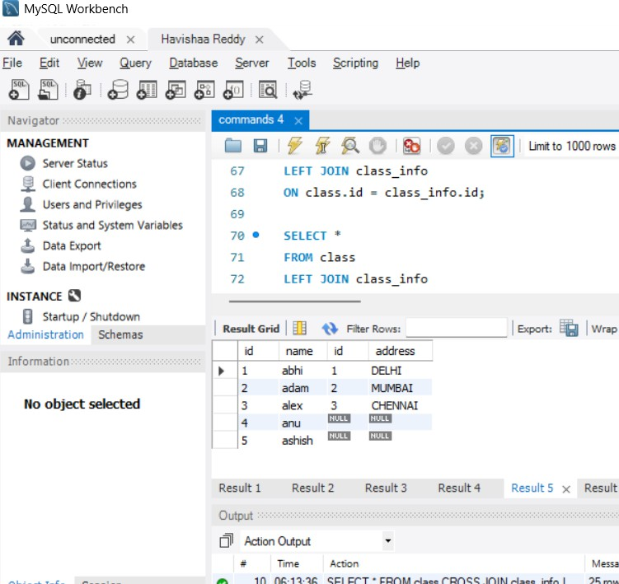

QUESTION 6 - LEFT JOIN
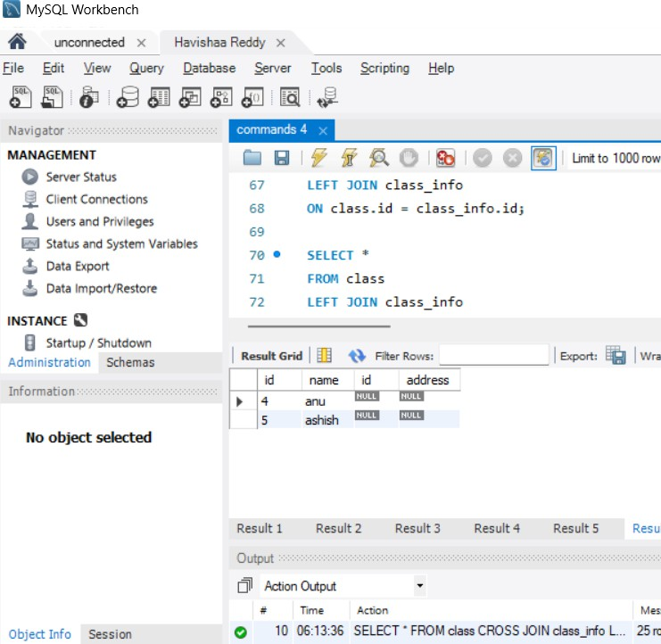

QUESTION 7 - RIGHT JOIN

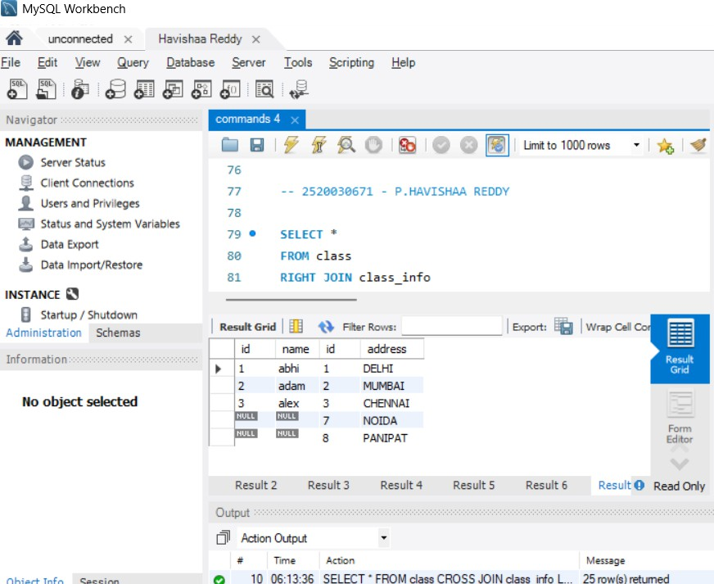

QUESTION 8 - RIGHT JOIN
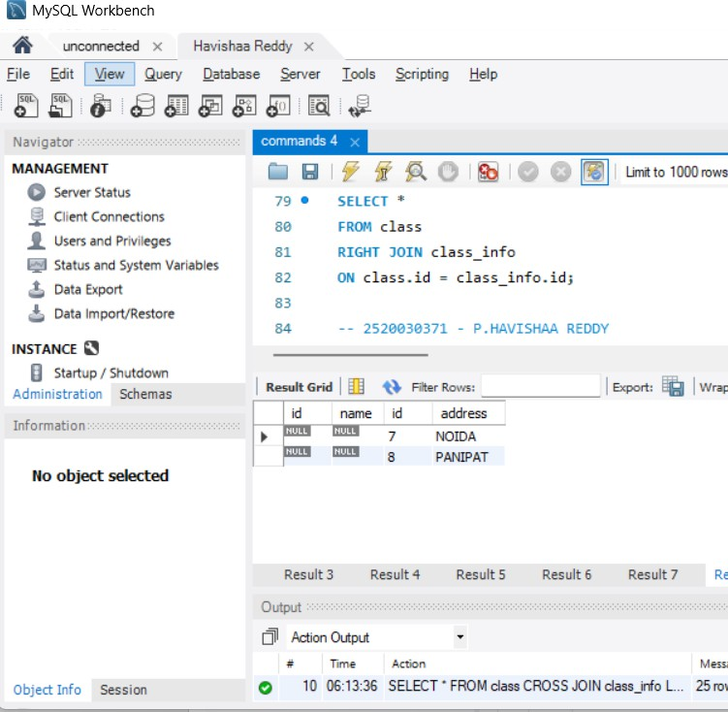

QUESTION 9 - FULL OUTER JOIN

